Monotile Tessellation
# Source: AI Source: Provided by: [Data Path: Persons Table -> ID Column: 1, Name_En Column: Motasem Essam] -> From: [ChatGPT] on [7/25/2026]
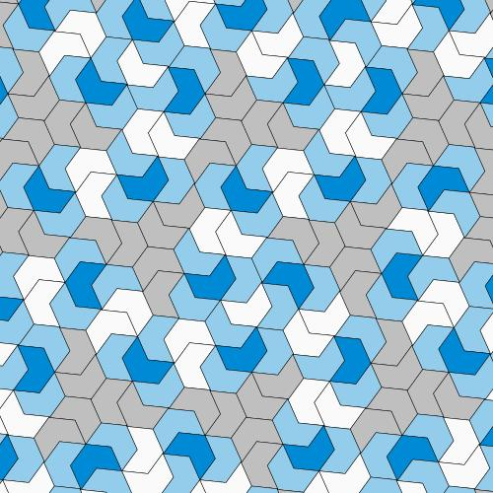
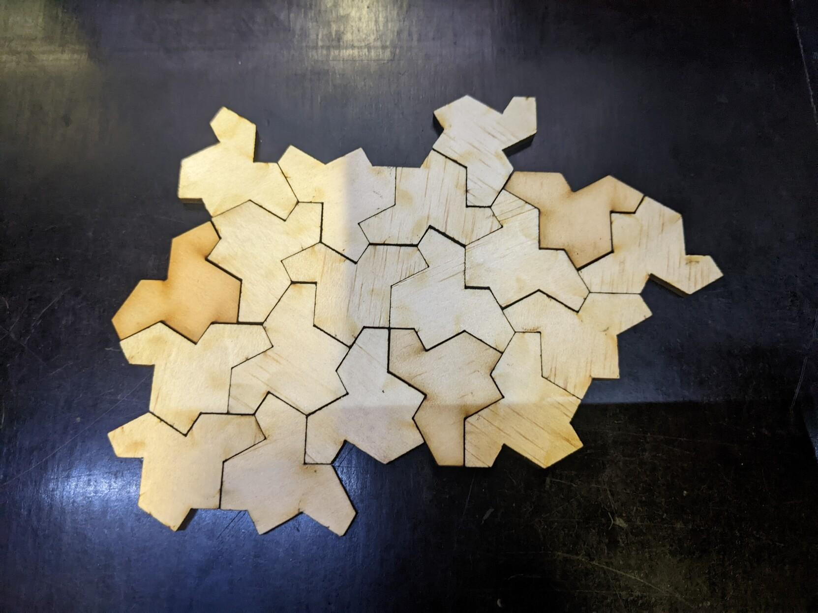
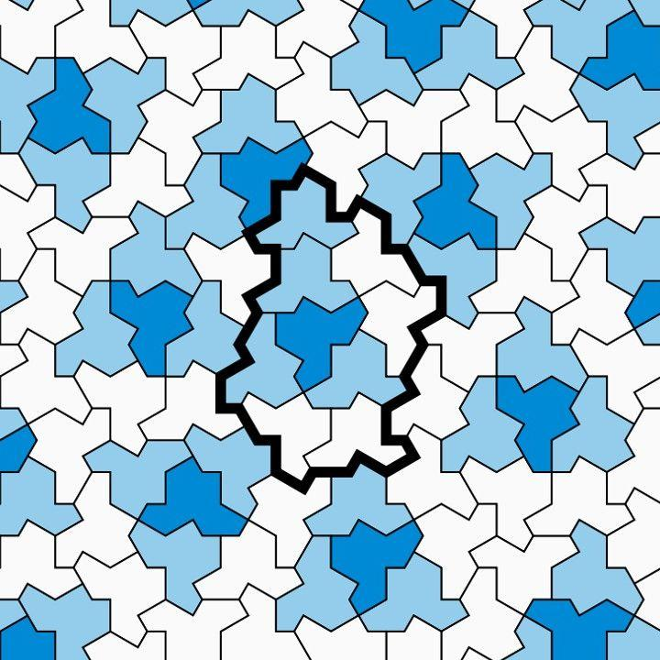
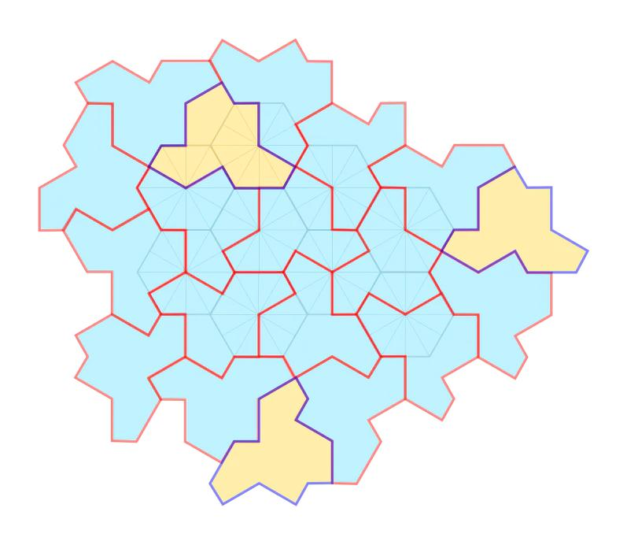
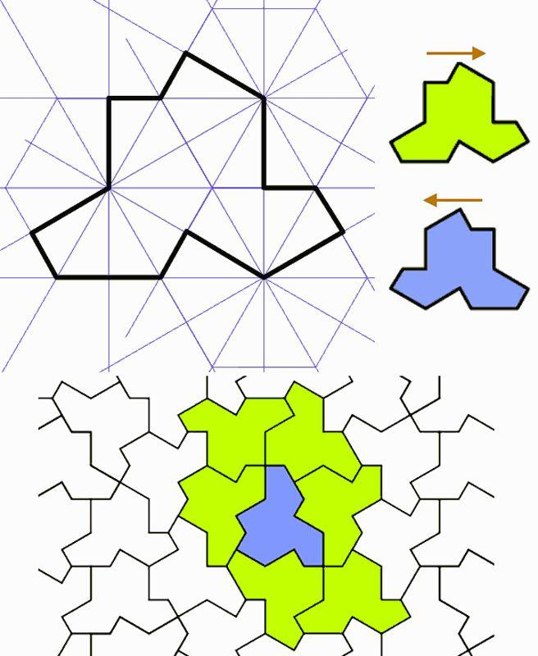

Definition
# Source: AI Source: Provided by: [Data Path: Persons Table -> ID Column: 1, Name_En Column: Motasem Essam] -> From: [ChatGPT] on [7/25/2026]
A Monotile Tessellation is a tessellation of the plane that uses one basic tile shape, called a monotile, repeatedly to cover the plane without gaps or overlaps.
The word monotile means that there is only one prototile shape from which the tiles are made.
However, an important distinction is needed:
Monotile does not automatically mean irregular or aperiodic.
For example, squares can form a tessellation using only one tile shape, but the square tessellation is regular, not irregular.
Therefore, in a classification of Irregular Tessellations, the term monotile tessellation should refer specifically to a tessellation using a single irregular tile shape. The general concept of a monotile is broader. (Living Textbook)

Basic Structure
# Source: AI Source: Provided by: [Data Path: Persons Table -> ID Column: 1, Name_En Column: Motasem Essam] -> From: [ChatGPT] on [7/25/2026]
A monotile tessellation has:
$$\boxed{\text{One Tile Shape}→\text{Repeated Copies}→\text{Complete Plane}}$$
The copies of the tile can generally be:
- translated,
- rotated,
- and, depending on the tiling, reflected.
The copies fit together to cover the plane without gaps or overlaps. (Math Is Fun)
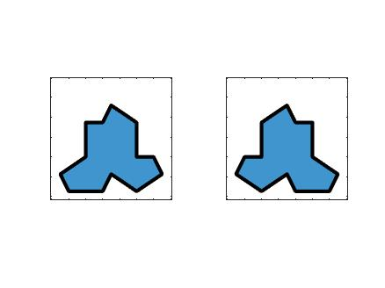
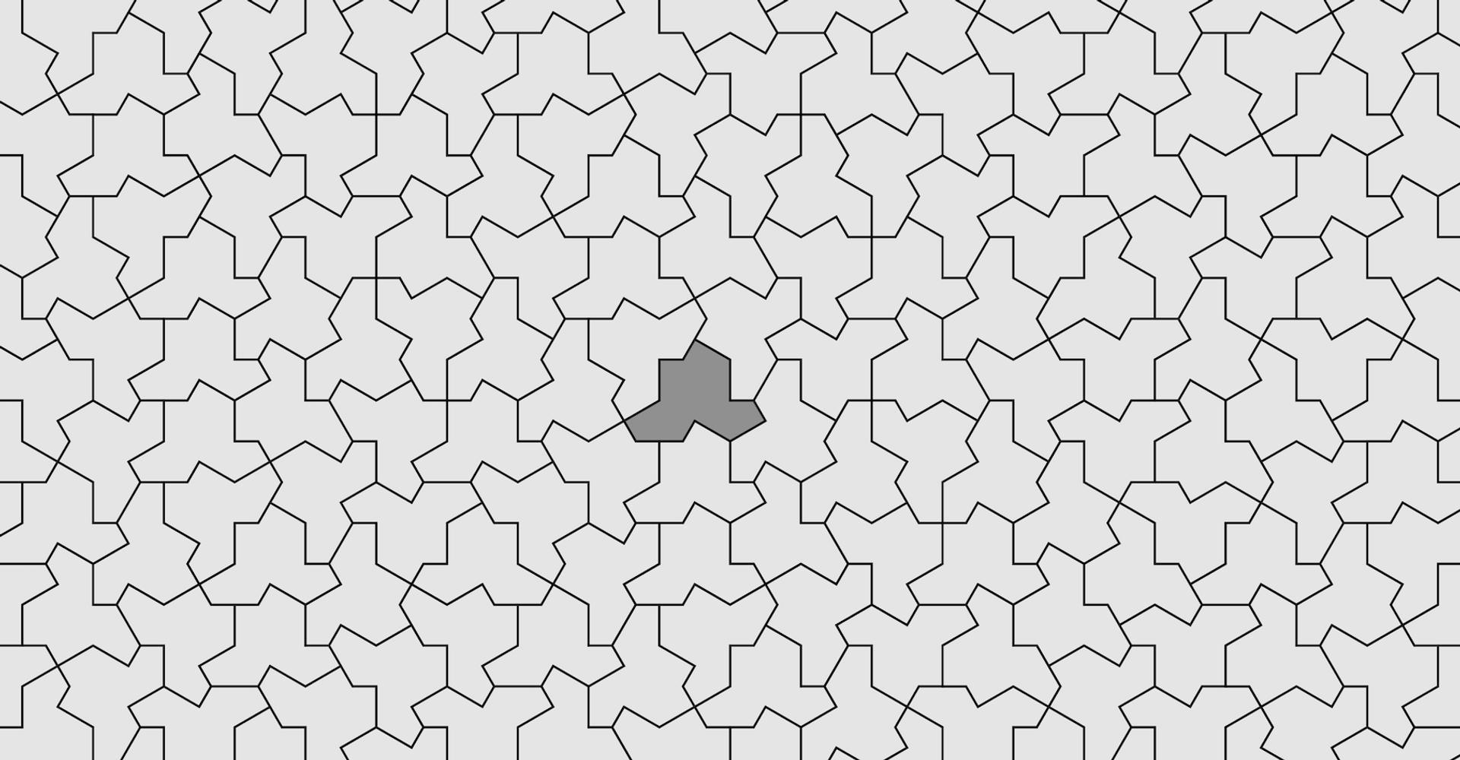
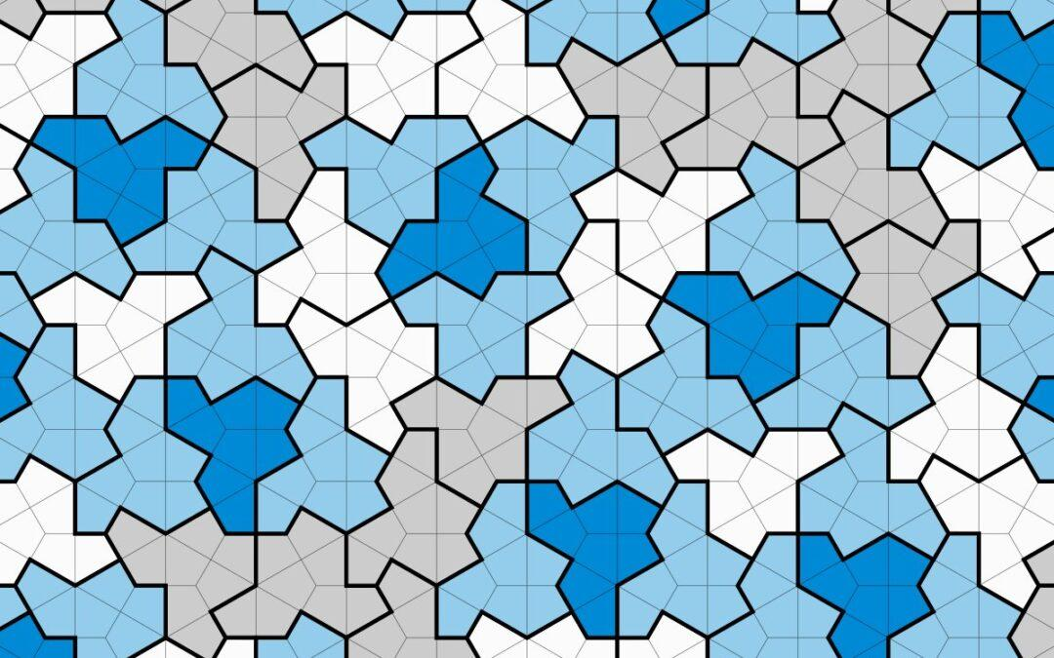
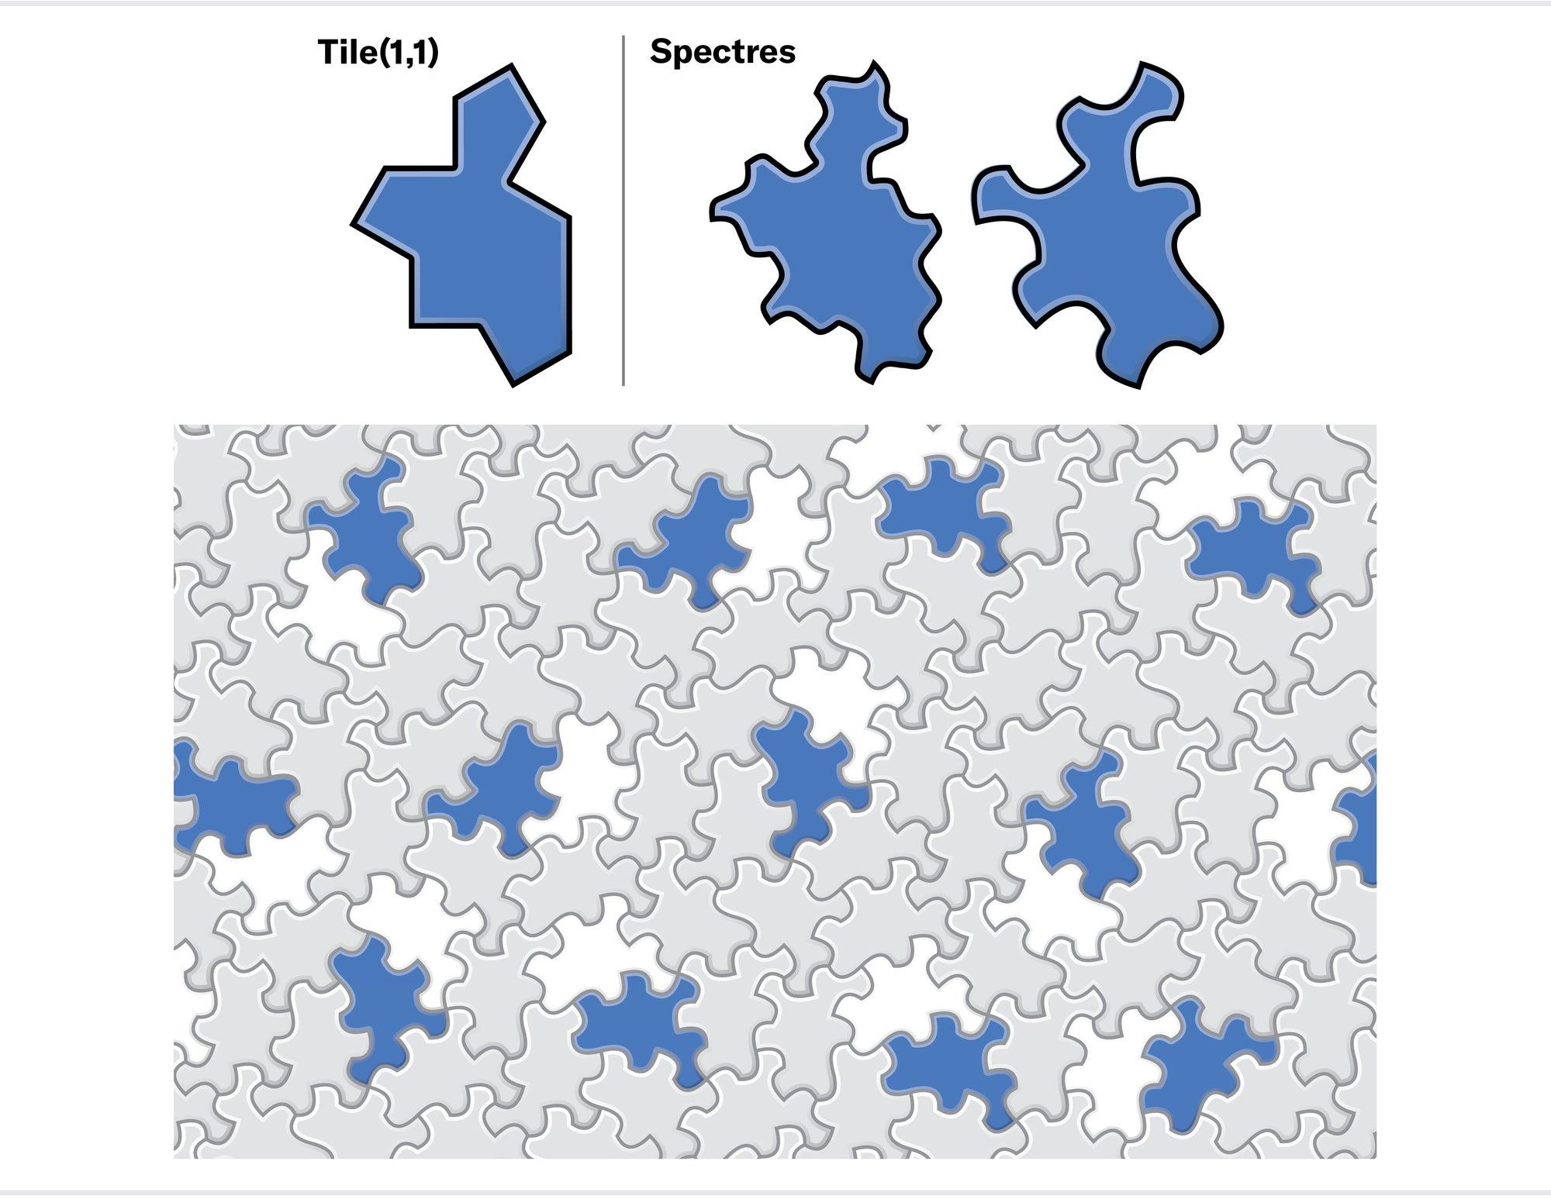

The Einstein Hat — Important Example
# Source: AI Source: Provided by: [Data Path: Persons Table -> ID Column: 1, Name_En Column: Motasem Essam] -> From: [ChatGPT] on [7/25/2026]
One of the most important modern examples is the Hat monotile.
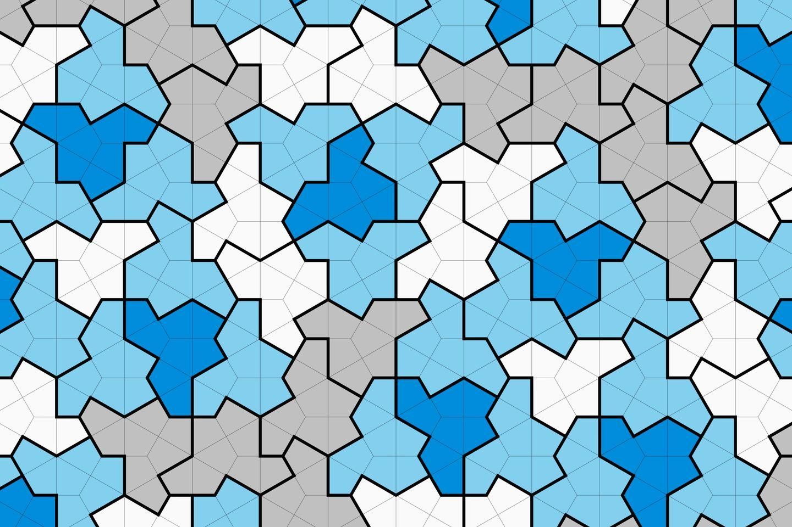
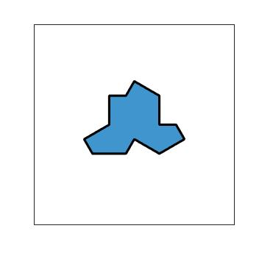
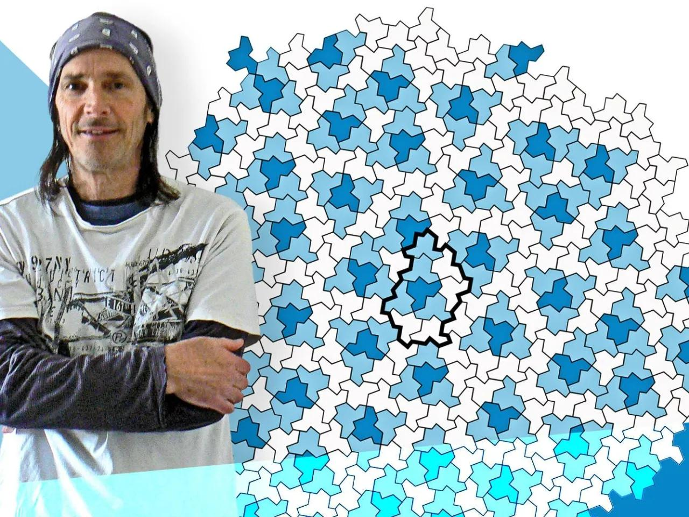
The Hat is an irregular, 13-sided polygon discovered by David Smith and studied with Joseph Samuel Myers, Craig S. Kaplan, and Chaim Goodman-Strauss.
In 2023, the researchers proved that copies of this single shape can tile the plane but cannot produce a periodic tiling. This made the Hat the first known aperiodic monotile, solving the long-standing "einstein" problem. (arXiv)
The Hat therefore has two important properties:
- Monotile — one basic shape is sufficient.
- Aperiodic — no translationally repeating tiling is possible.
So:
$$\boxed{\text{Hat}=\text{Aperiodic Monotile}}$$

What Does "Monotile" Mean?
# Source: AI Source: Provided by: [Data Path: Persons Table -> ID Column: 1, Name_En Column: Motasem Essam] -> From: [ChatGPT] on [7/25/2026]
The word can be broken down as:
Mono = one
Tile = a shape used to cover a surface
Therefore:
$$\boxed{\text{Monotile}=\text{one prototile shape}}$$
A prototile is the basic shape from which the tiles in a tiling are generated. (Wikipedia)
For example:
Square tessellation
◼️ ◼️ ◼️
◼️ ◼️ ◼️
◼️ ◼️ ◼️
Uses one shape:
$$\boxed{\text{Square}}$$
But it is regular, not irregular.
Hat monotile
The same irregular Hat shape is repeatedly used:
🟩 → 🟩 → 🟩 → ...
but its copies can have different orientations.
That is a monotile tessellation.

Monotile vs Aperiodic Monotile
# Source: AI Source: Provided by: [Data Path: Persons Table -> ID Column: 1, Name_En Column: Motasem Essam] -> From: [ChatGPT] on [7/25/2026]
These terms should not be treated as synonyms.
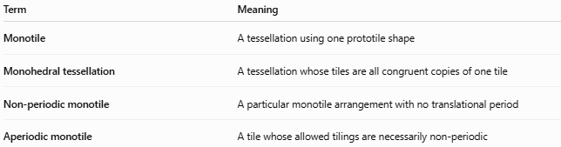
Term | Meaning
Monotile | A tessellation using one prototile shape
Monohedral tessellation | A tessellation whose tiles are all congruent copies of one tile
Non-periodic monotile | A particular monotile arrangement with no translational period
Aperiodic monotile | A tile whose allowed tilings are necessarily non-periodic
The last category is the strongest.
An ordinary monotile may be capable of periodic tilings. An aperiodic monotile cannot produce a periodic tiling. (untiling.com)

Why the Hat Is Special
# Source: AI Source: Provided by: [Data Path: Persons Table -> ID Column: 1, Name_En Column: Motasem Essam] -> From: [ChatGPT] on [7/25/2026]
The Hat is particularly important because it does not merely happen to have one non-repeating arrangement.
The mathematical result shows that the Hat forces aperiodicity: every tiling of the plane using the Hat obeys constraints that prevent translational periodicity. (Cheriton School of Computer Science)
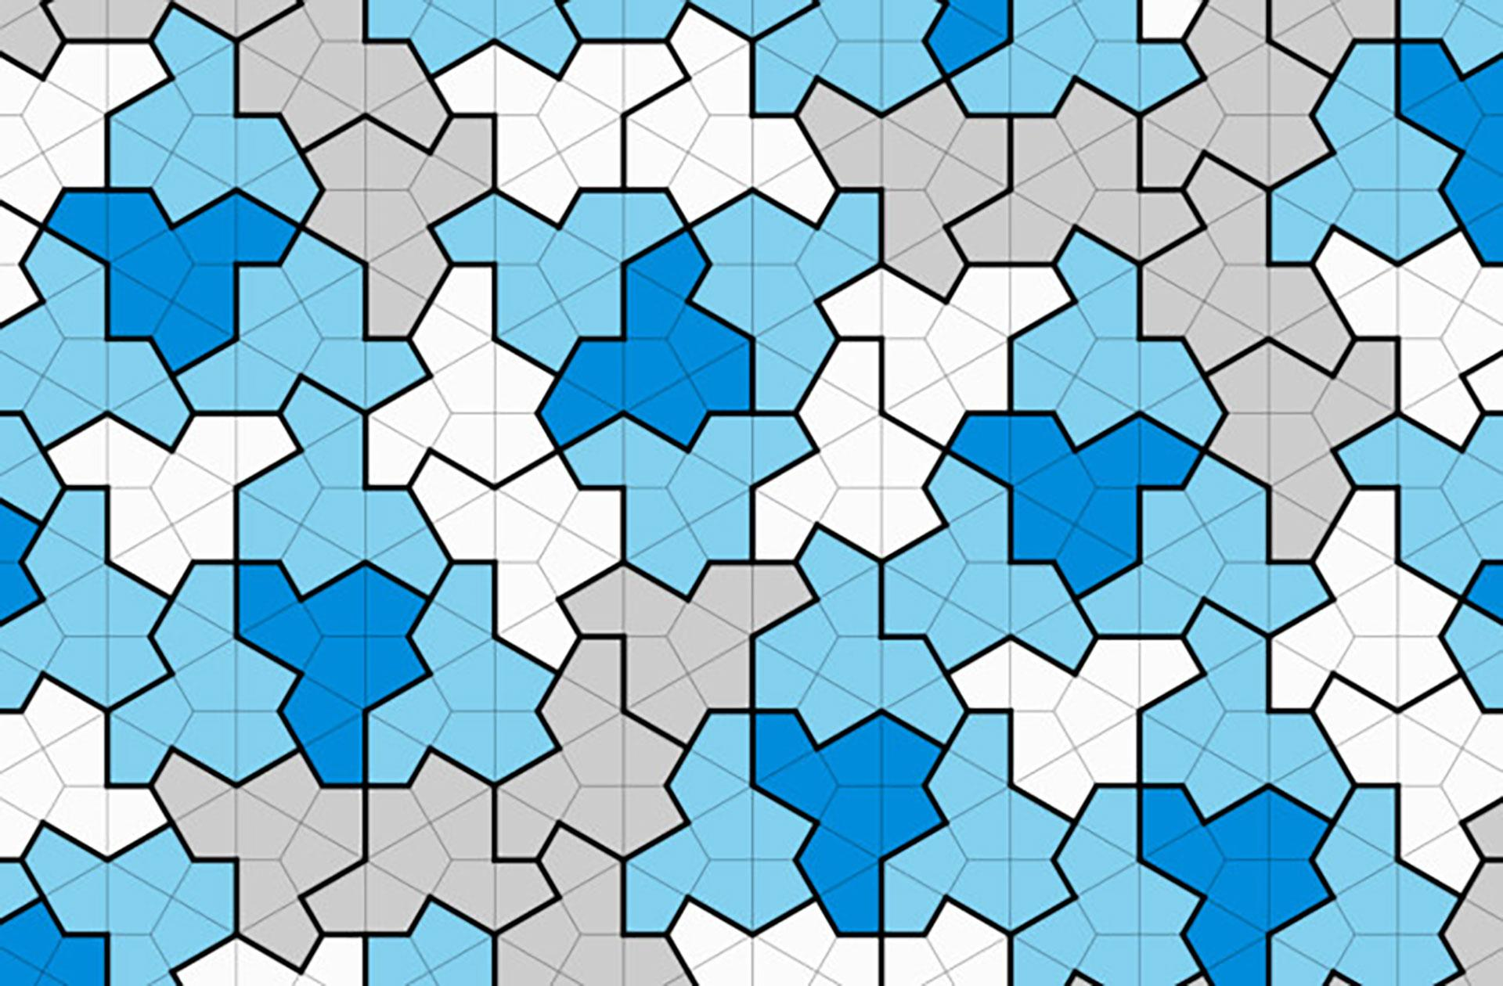
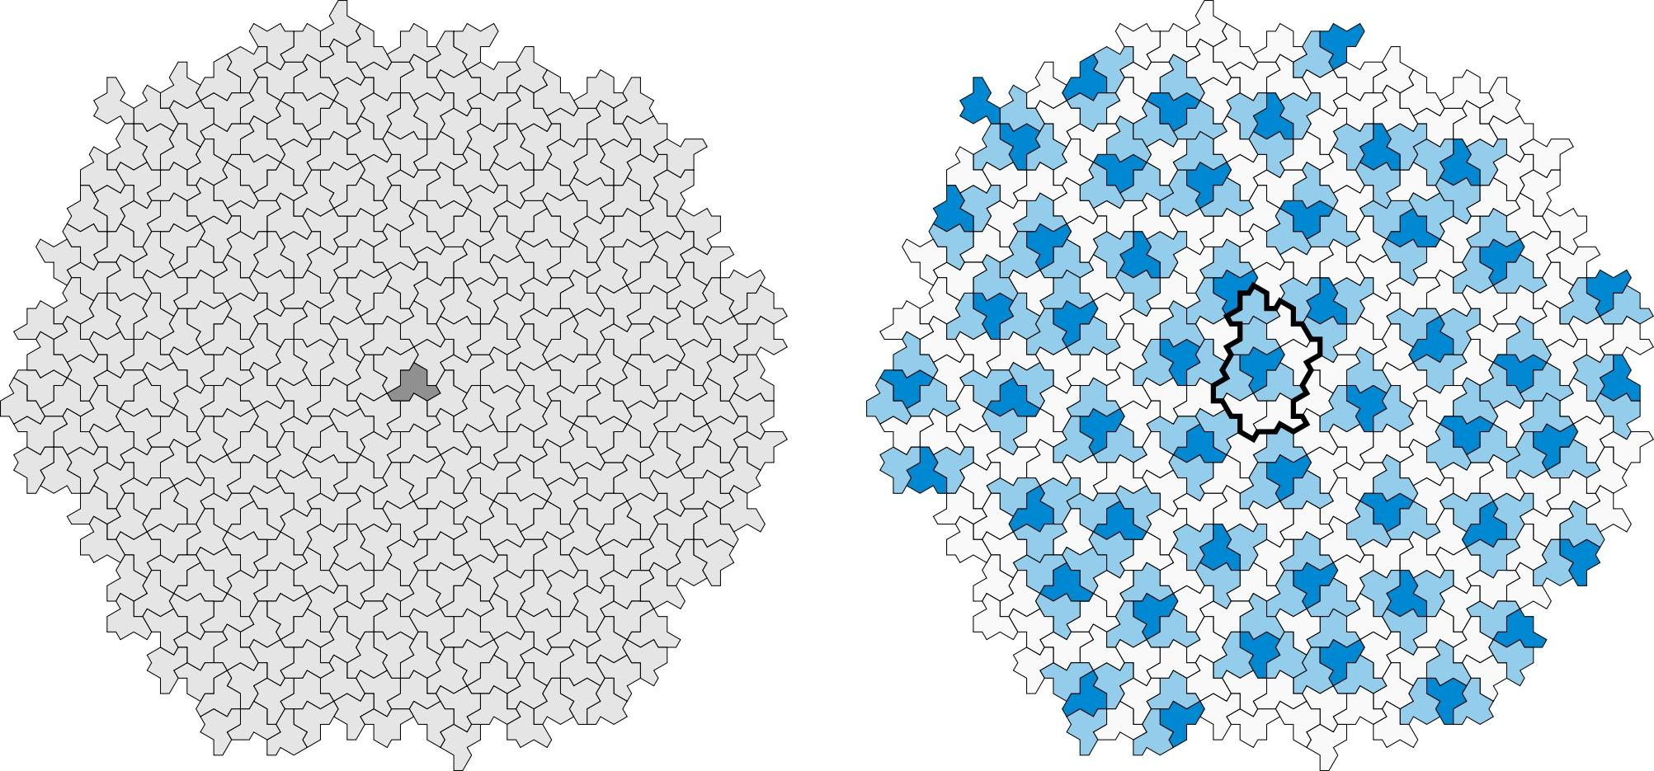
The resulting pattern can be highly organized and hierarchical even though it never repeats periodically.
So:
$$\boxed{\text{Non-periodic}≠\text{Random}}$$
An aperiodic tessellation can have considerable mathematical structure.

Classification
# Source: AI Source: Provided by: [Data Path: Persons Table -> ID Column: 1, Name_En Column: Motasem Essam] -> From: [ChatGPT] on [7/25/2026]
For your Plane Geometry knowledge base, I recommend organizing it as:
Tessellations
→ Irregular Tessellations
→ Monotile Tessellation
But add the following clarification:
Monotile is a classification by the number of prototile shapes, whereas "irregular" is a classification by the geometric nature of the tile. Therefore, not every monotile tessellation is irregular.
This distinction is important because a square tessellation is also a monotile tessellation in the broad sense, but it is a regular tessellation. (MathWorld)

Properties
# Source: AI Source: Provided by: [Data Path: Persons Table -> ID Column: 1, Name_En Column: Motasem Essam] -> From: [ChatGPT] on [7/25/2026]
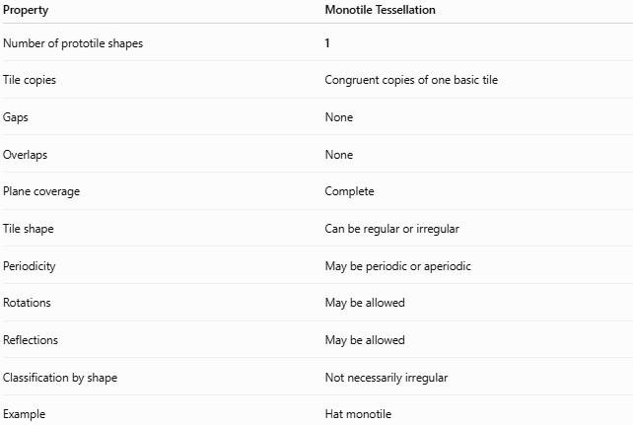
Property | Monotile Tessellation
Number of prototile shapes | 1
Tile copies | Congruent copies of one basic tile
Gaps | None
Overlaps | None
Plane coverage | Complete
Tile shape | Can be regular or irregular
Periodicity | May be periodic or aperiodic
Rotations | May be allowed
Reflections | May be allowed
Classification by shape | Not necessarily irregular
Example | Hat monotile

Monotile vs Other Tessellations
# Source: AI Source: Provided by: [Data Path: Persons Table -> ID Column: 1, Name_En Column: Motasem Essam] -> From: [ChatGPT] on [7/25/2026]
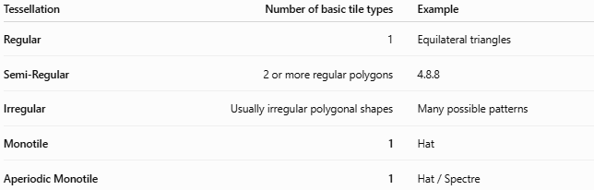
Tessellation | Number of basic tile types | Example
Regular | 1 | Equilateral triangles
Semi-Regular | 2 or more regular polygons | 4.8.8
Irregular | Usually irregular polygonal shapes | Many possible patterns
Monotile | 1 | Hat
Aperiodic Monotile | 1 | Hat / Spectre
Notice that Monotile and Irregular describe different aspects of a tessellation.

Key Points
# Source: AI Source: Provided by: [Data Path: Persons Table -> ID Column: 1, Name_En Column: Motasem Essam] -> From: [ChatGPT] on [7/25/2026]
- A monotile tessellation uses one basic tile shape.
- Copies of that tile cover the plane without gaps or overlaps.
- The tile can be translated, rotated, and sometimes reflected.
- Monotile does not automatically mean irregular.
- A square grid is a simple monotile tessellation but is regular.
- An irregular monotile uses one irregular tile shape.
- The Hat is an important example of an irregular monotile.
- The Hat is more specifically an aperiodic monotile.
- An aperiodic monotile tiles the plane but cannot form a periodic tiling. (Cheriton School of Computer Science)
- Aperiodic does not mean random; the Hat tilings have a structured mathematical organization.

Conclusion
# Source: AI Source: Provided by: [Data Path: Persons Table -> ID Column: 1, Name_En Column: Motasem Essam] -> From: [ChatGPT] on [7/25/2026]
$$\boxed{\text{Monotile Tessellation}=\text{Tessellation using one basic tile shape}}$$
For your Irregular Tessellations classification, the more precise concept is:
$$\boxed{\text{Irregular Monotile Tessellation}}$$
and the most famous modern example is:
$$\boxed{\text{Hat}=\text{Aperiodic Monotile}}$$
The Hat is especially significant because it uses one irregular shape to tile the entire plane while forcing a non-periodic pattern. (Cheriton School of Computer Science)

